Aggregate Functions

- COUNT Function

Count fun is used to count the column values.

- SELECT COUNT(*) FROM books;

- SELECT COUNT(author_lname) FROM books;

- SELECT COUNT(DISTINCT author_lname) FROM books;

- SELECT COUNT(*) FROM books WHERE title LIKE '%the%';

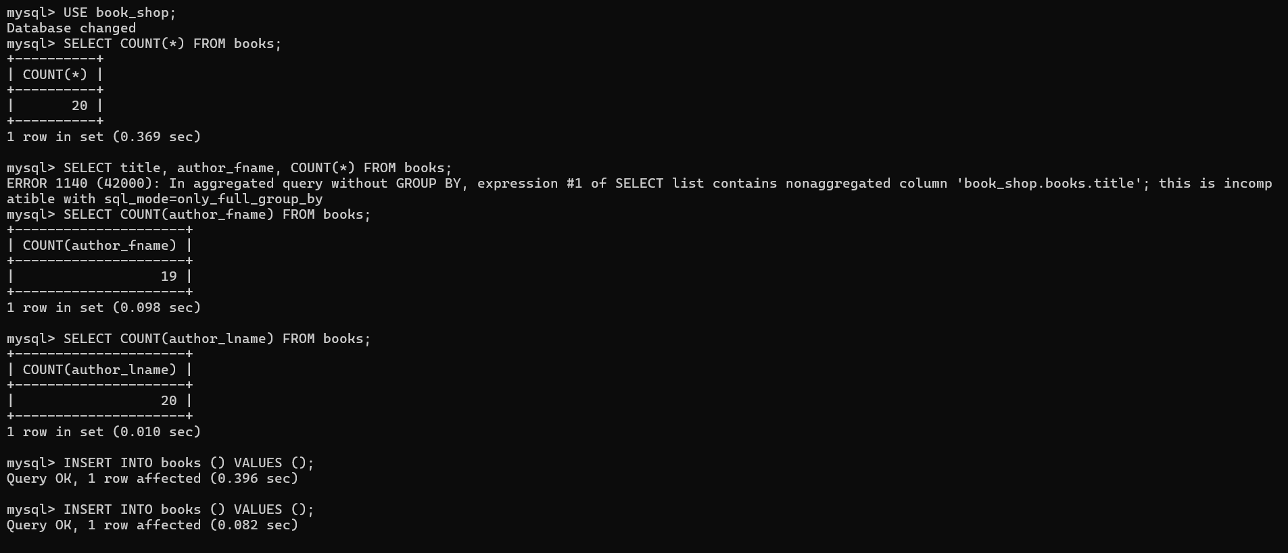

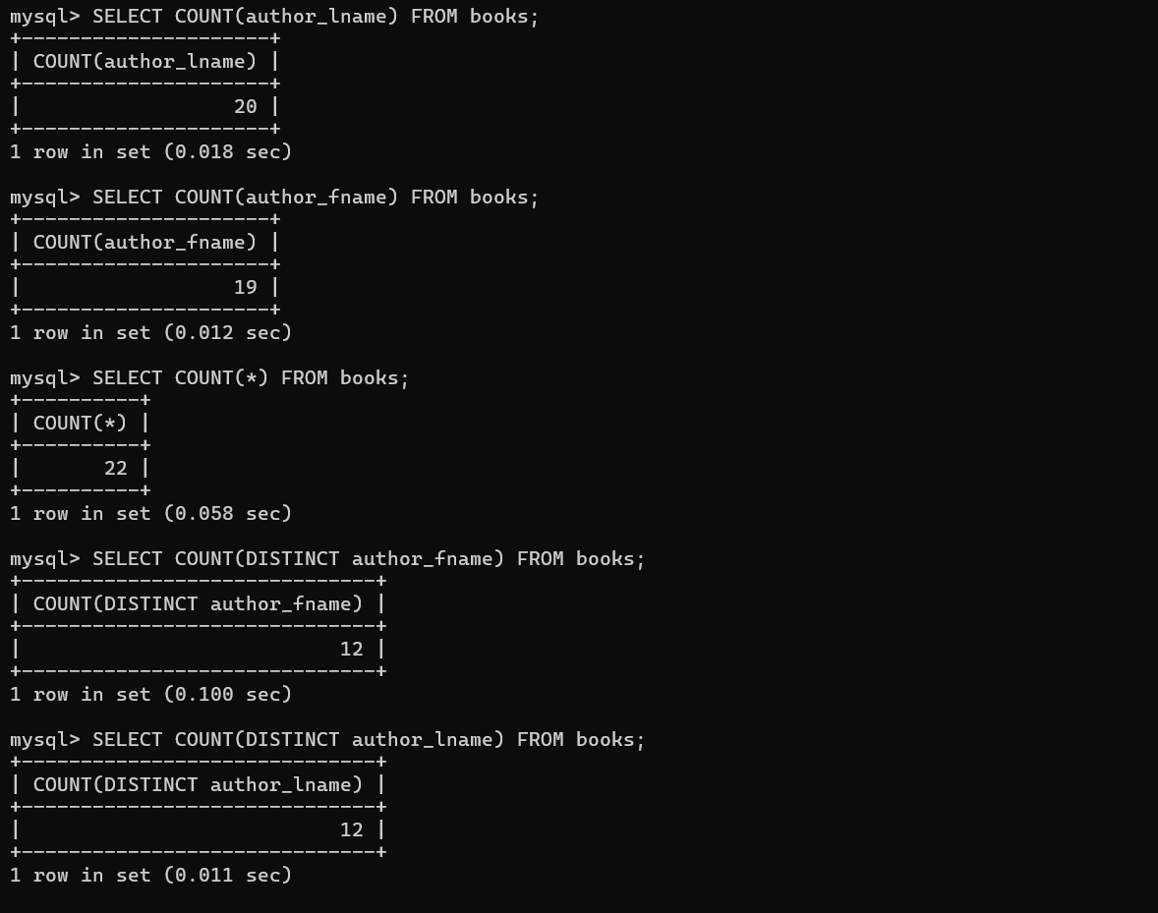

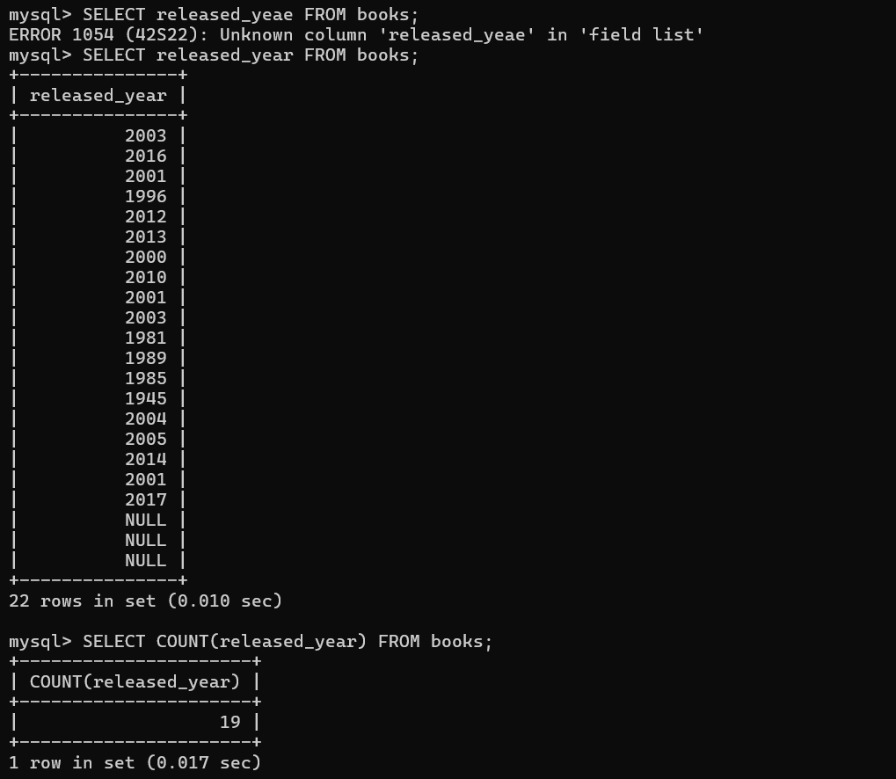

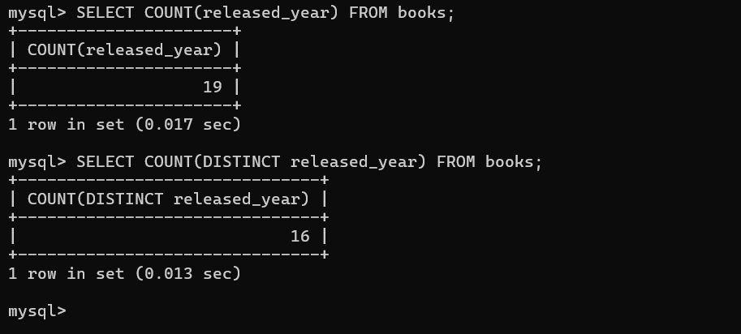

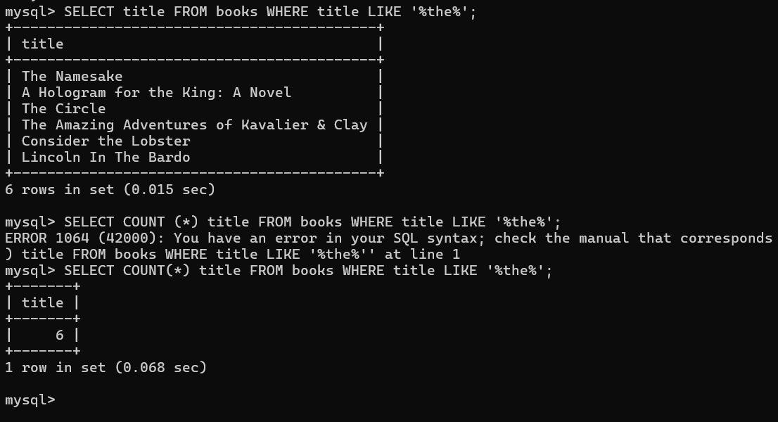

- ORDER Function using GROUP BY

Summarizes or aggregates identical data into single rows.

- SELECT author_lname, COUNT(*)
- FROM books
- GROUP BY author_lname;

- SELECT
- author_lname, COUNT(*) AS books_written
- FROM
- books
- GROUP BY author_lname
- ORDER BY books_written DESC;

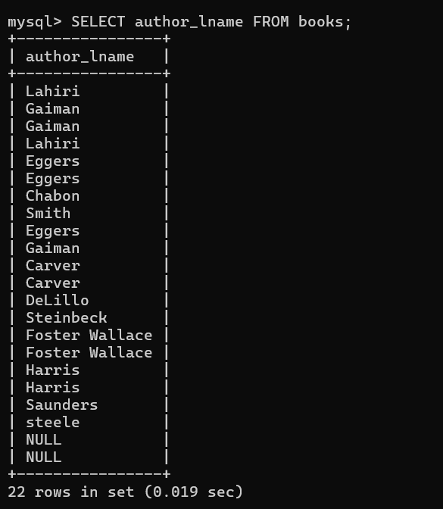

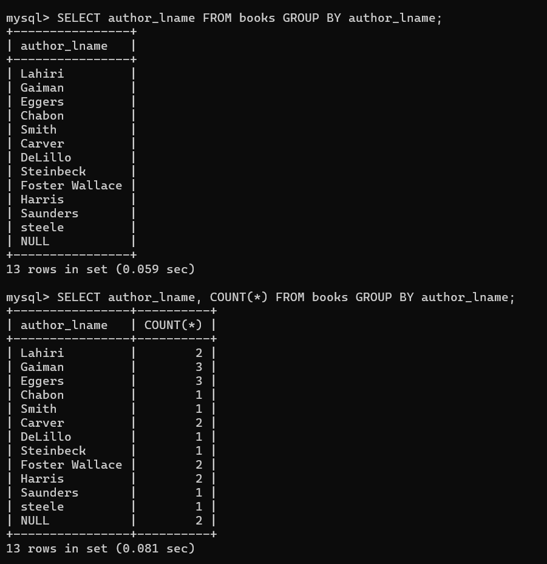

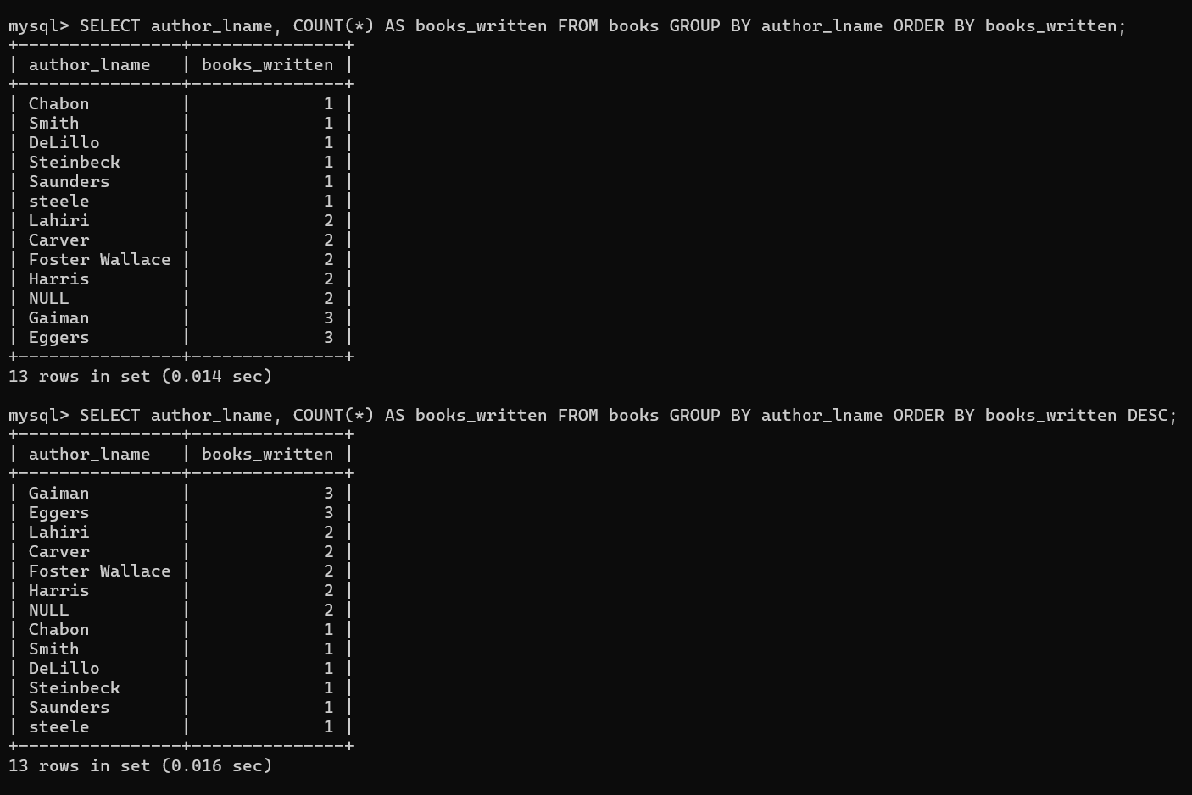

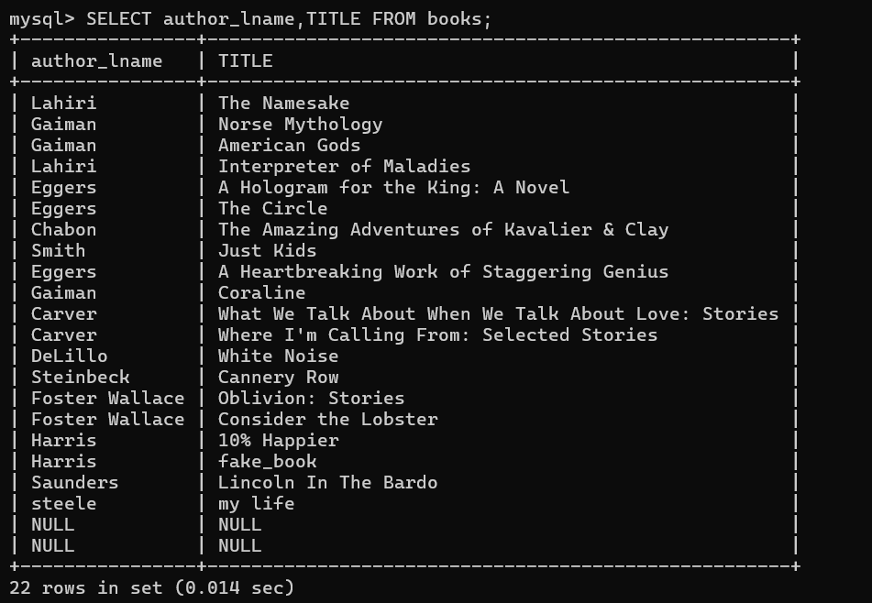

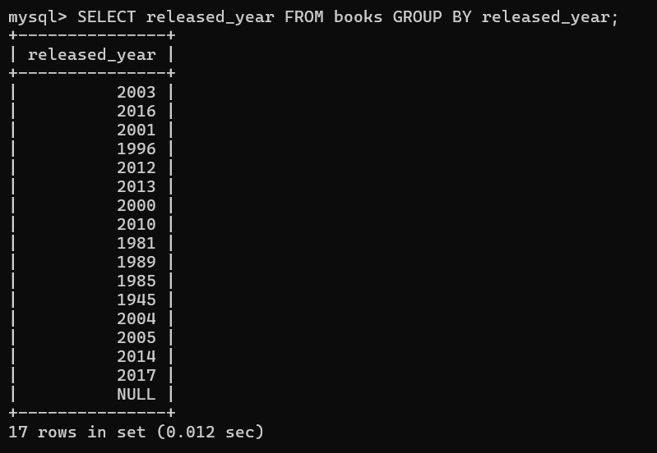

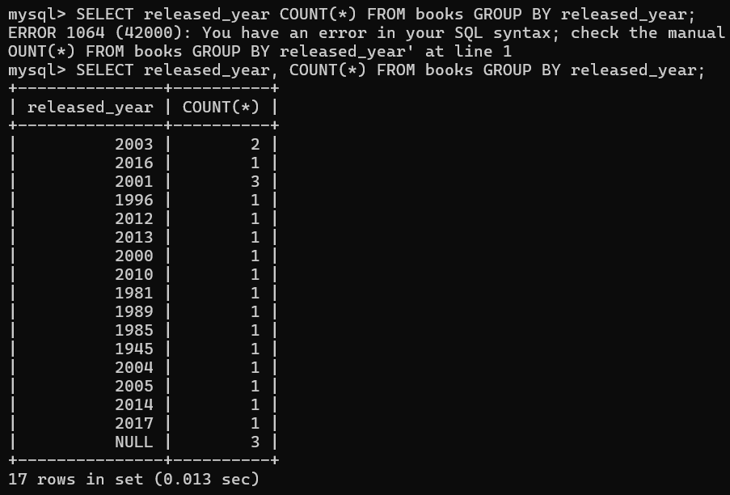

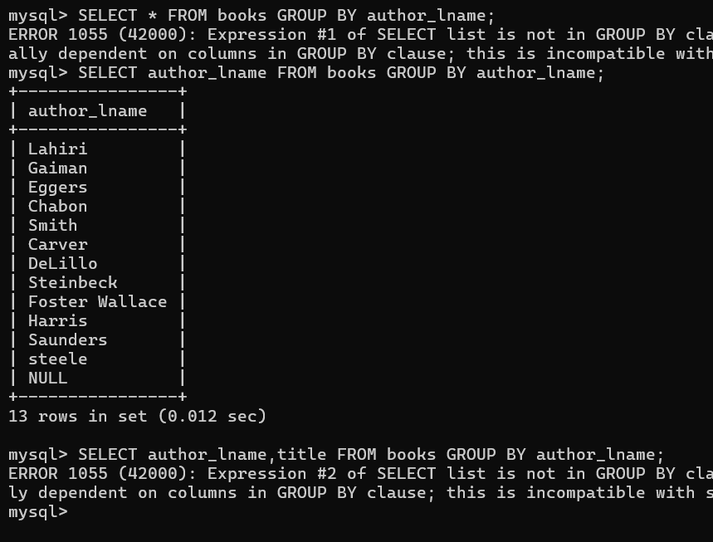

- MIN AND MAX

Min and Max value in certain groups.

- SELECT MAX(pages) FROM books;

- SELECT MIN(author_lname) FROM books;
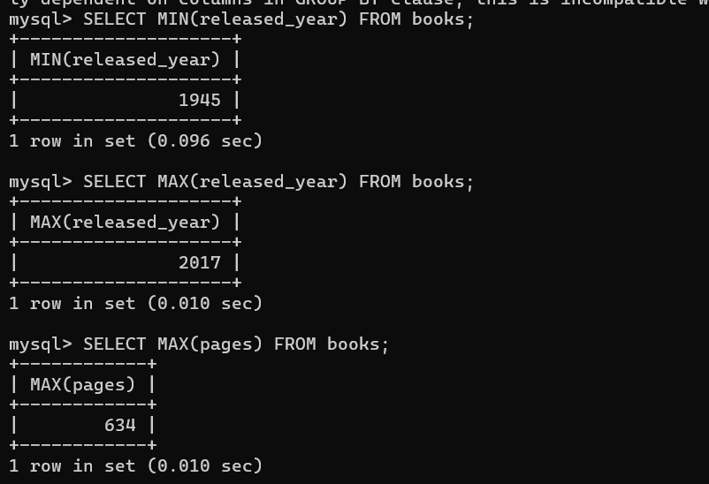

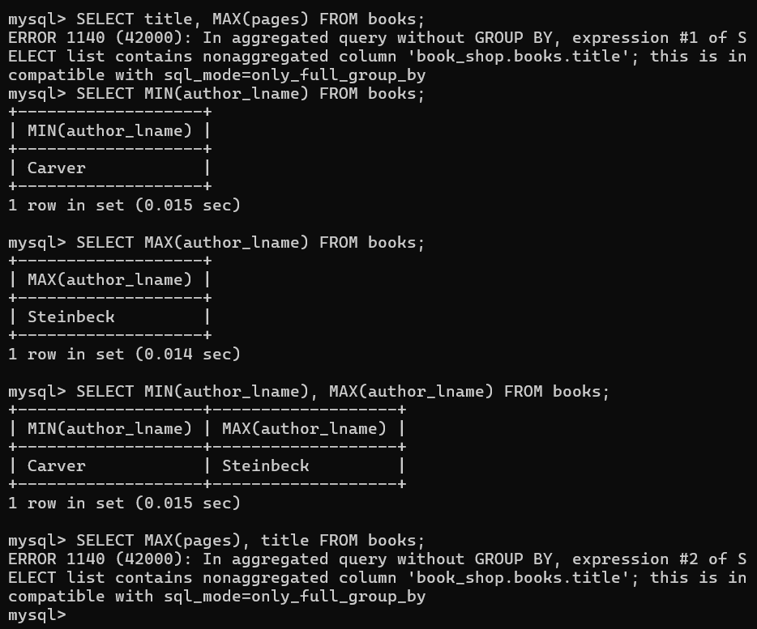

- SUBQUERIES

- SELECT title, pages FROM books
- WHERE pages = (SELECT MAX(pages) FROM books);

- SELECT MIN(released_year) FROM books;

- SELECT title, released_year FROM books
- WHERE released_year = (SELECT MIN(released_year) FROM books);

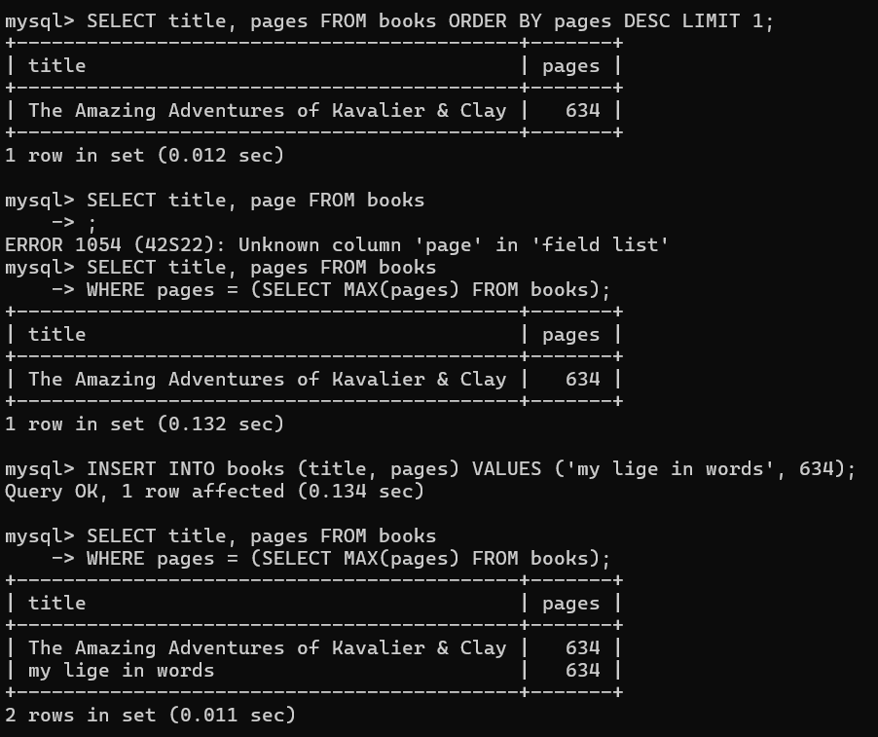

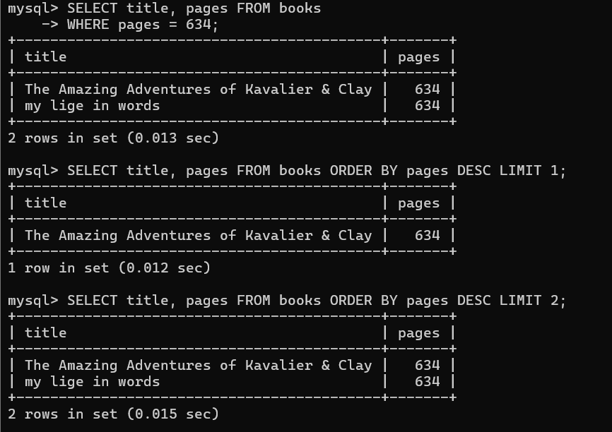

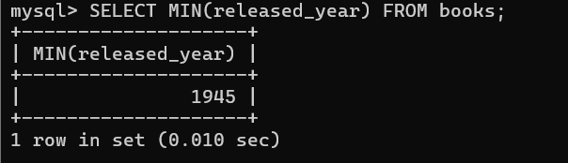

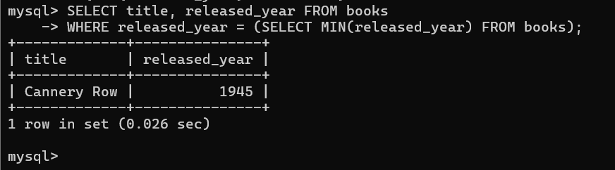

- Grouping by Multiple Columns

- SELECT author_fname, author_lname, COUNT(*)
- FROM books
- GROUP BY author_lname, author_fname;

- SELECT CONCAT(author_fname, ' ', author_lname) AS author, COUNT(*)
- FROM books
- GROUP BY author;
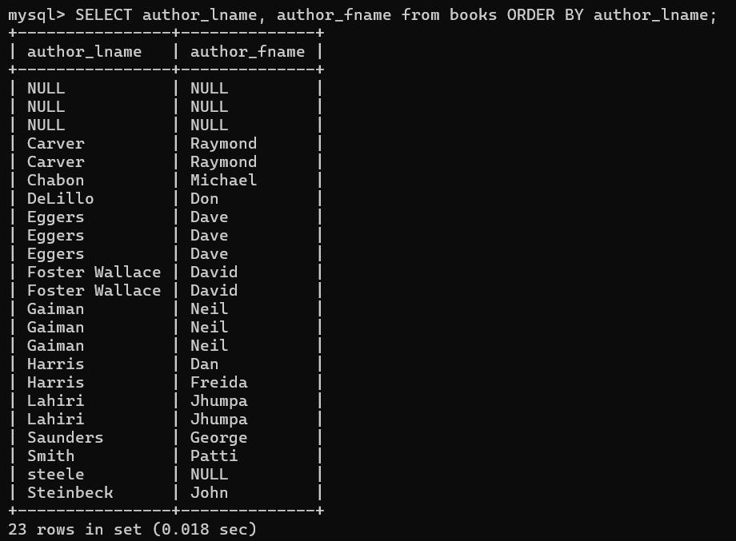

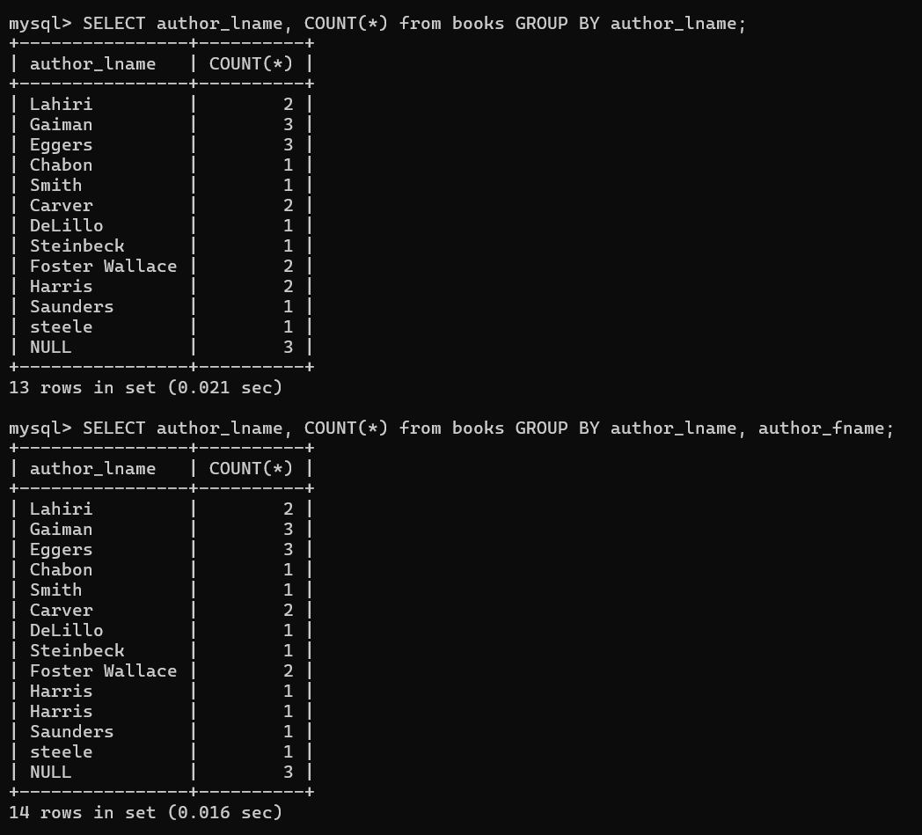

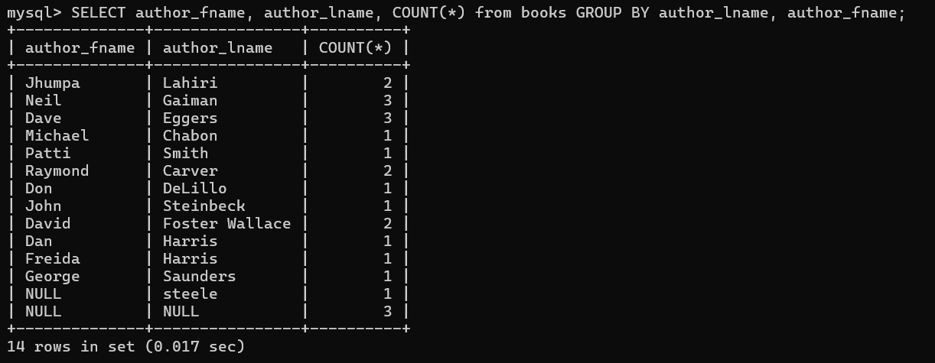

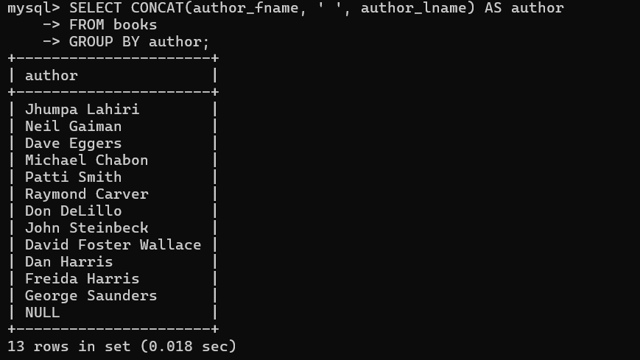

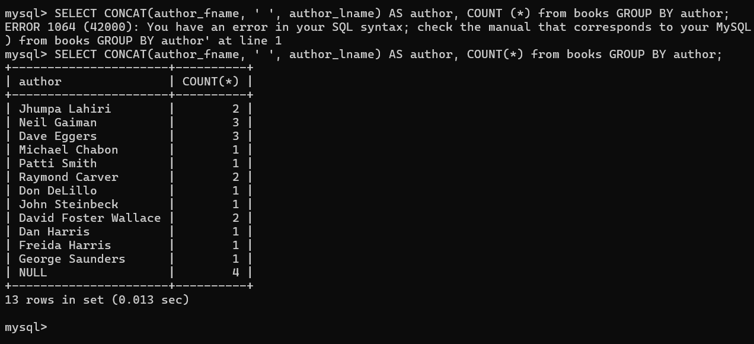

- Min and Max with GROUP BY

- SELECT author_lname, MIN(released_year) FROM books GROUP BY author_lname;

- SELECT author_lname, MAX(released_year), MIN(released_year) FROM books GROUP BY author_lname;

- SELECT
- author_lname,
- COUNT(*) as books_written,
- MAX(released_year) AS latest_release,
- MIN(released_year) AS earliest_release,
- MAX(pages) AS longest_page_count
- FROM books GROUP BY author_lname;

- SELECT
- author_lname,
- author_fname,
- COUNT(*) as books_written,
- MAX(released_year) AS latest_release,
- MIN(released_year) AS earliest_release
- FROM books GROUP BY author_lname, author_fname;

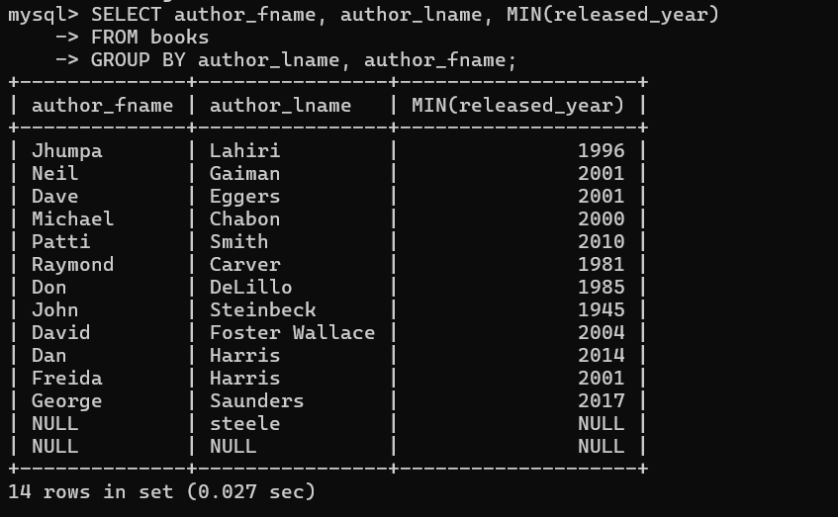

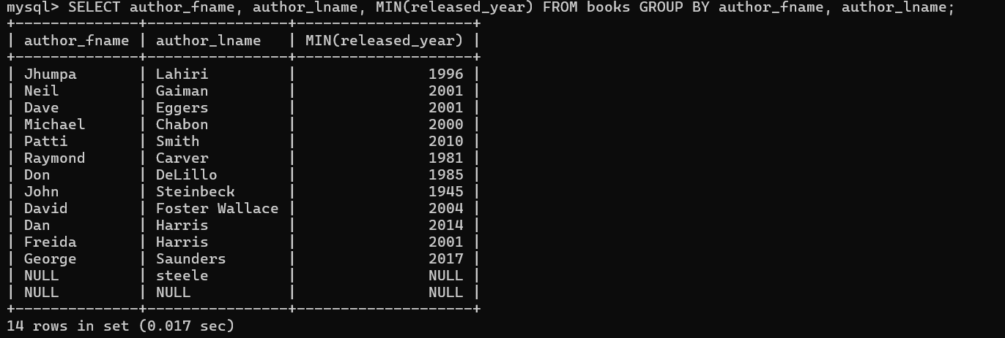

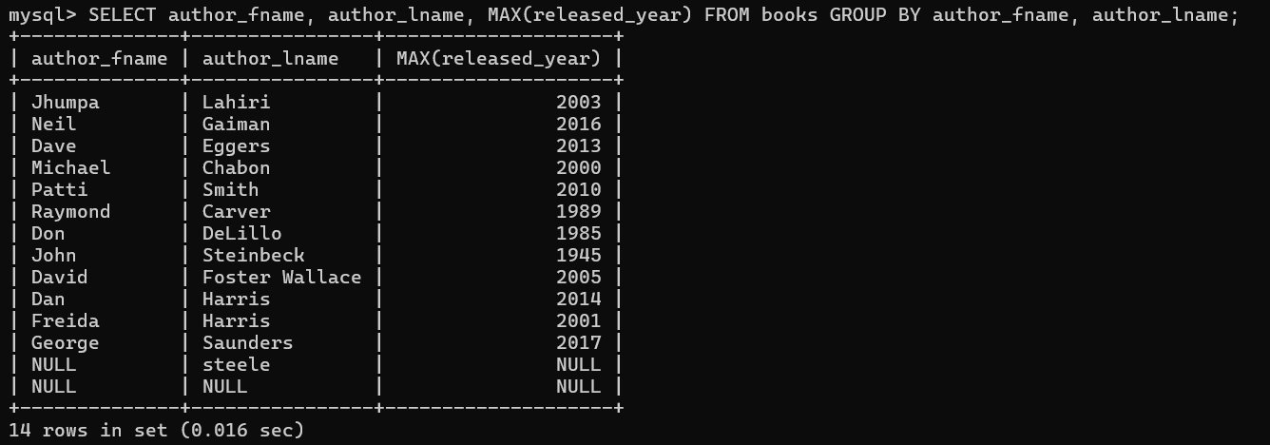

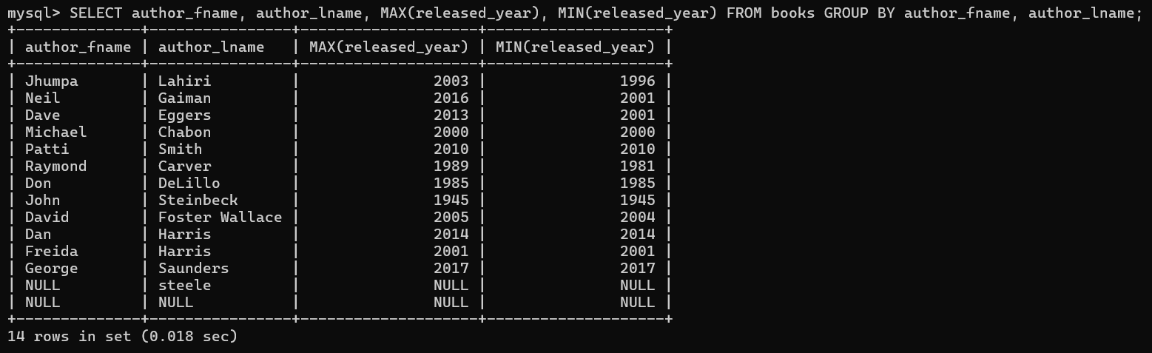

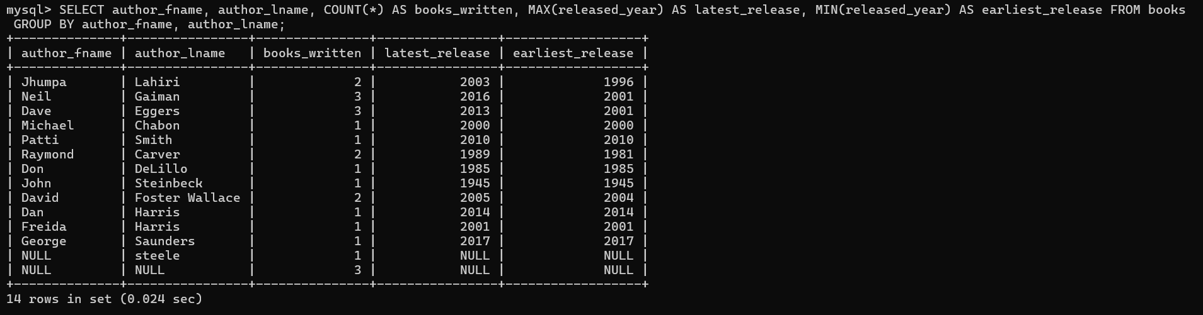

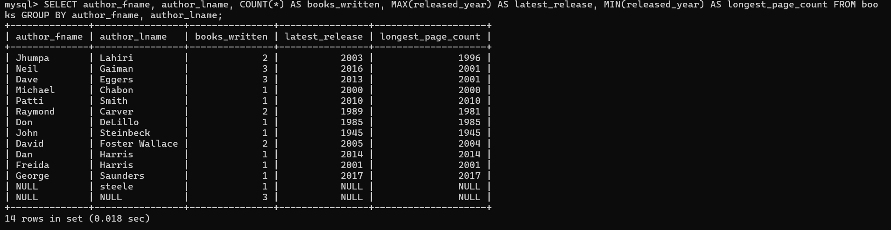

- Sum

Adds things together.

- SELECT SUM(pages) FROM books;

- SELECT author_lname, COUNT(*), SUM(pages)
- FROM books
- GROUP BY author_lname;
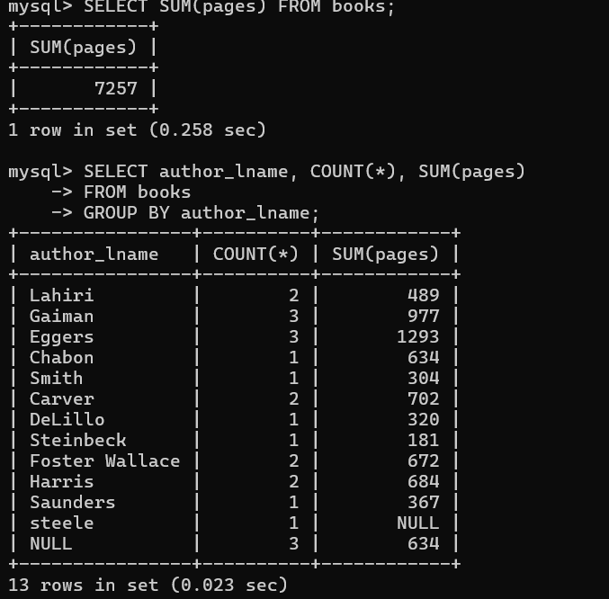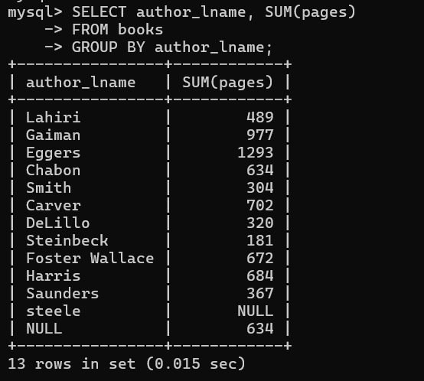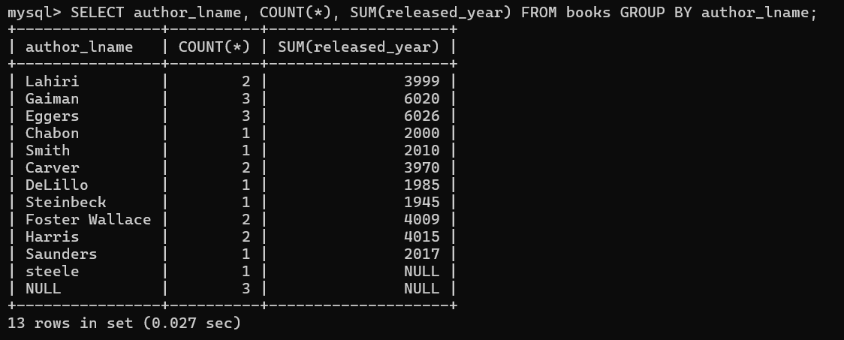

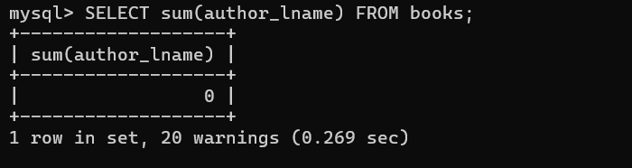

- Average

- SELECT AVG(pages) FROM books;

- SELECT AVG(released_year) FROM books;

- SELECT
- released_year,
- AVG(stock_quantity),
- COUNT(*) FROM books
- GROUP BY released_year;

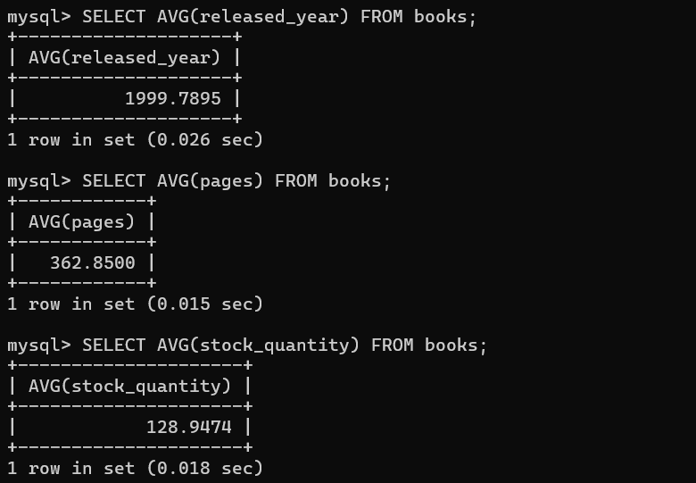

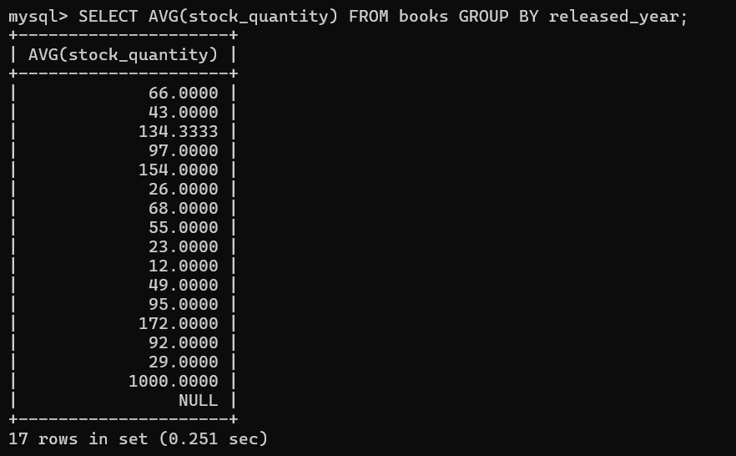

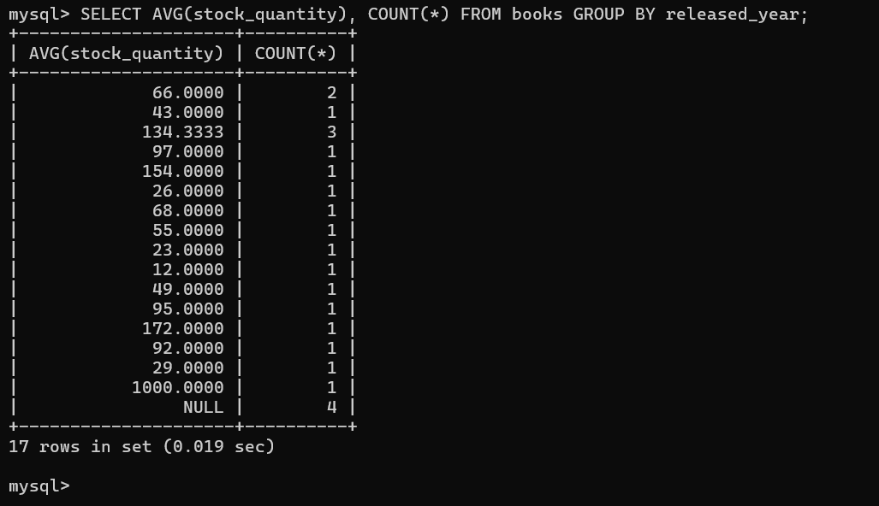

Exercise
- SELECT COUNT(*) FROM books;

- SELECT released_year, COUNT(*)
- FROM books GROUP BY released_year;

- SELECT SUM(stock_quantity) FROM books;

- SELECT AVG(released_year)
- FROM books GROUP BY author_lname, author_fname;

- SELECT CONCAT(author_fname, ' ', author_lname) AS author, pages FROM books
- WHERE pages = (SELECT MAX(pages) FROM books);

- SELECT CONCAT(author_fname, ' ', author_lname) AS author, pages FROM books
- ORDER BY pages DESC LIMIT 1;

- SELECT
- released_year AS year,
- COUNT(*) AS '# books',
- AVG(pages) AS 'avg pages'
- FROM books
- GROUP BY released_year
- ORDER BY released_year;

